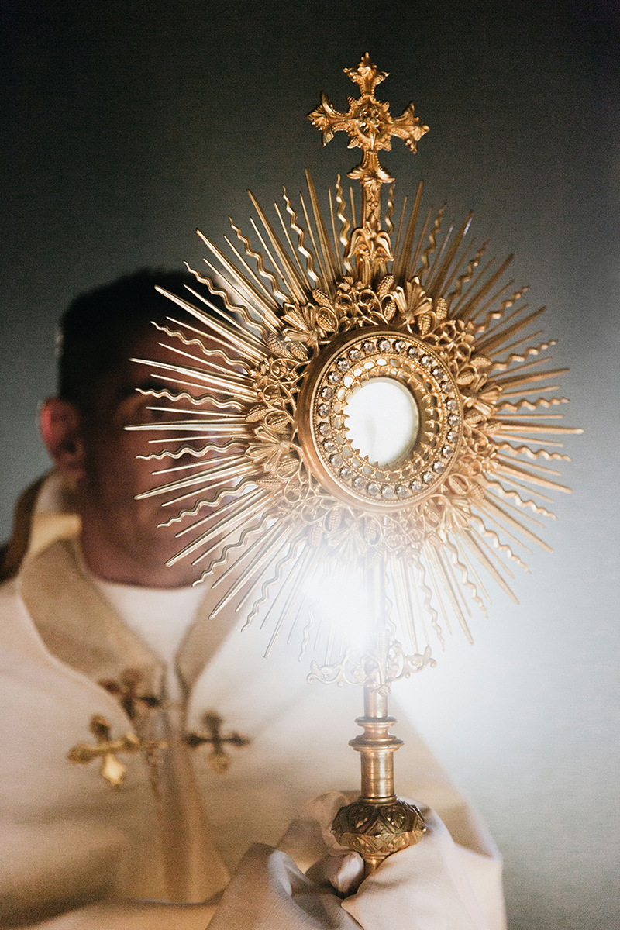
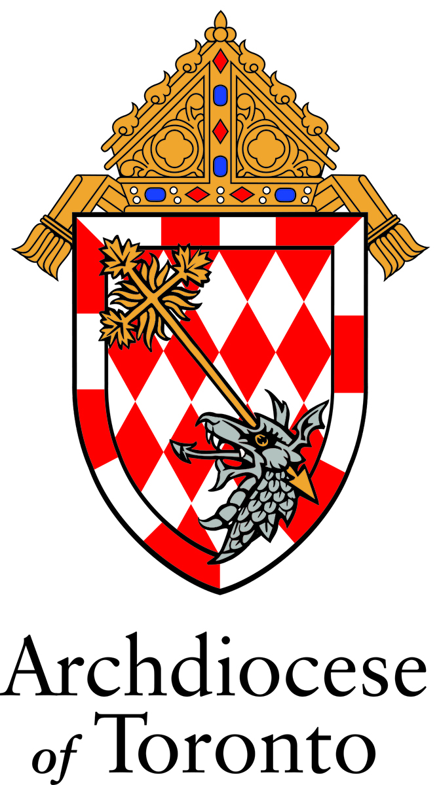
EUCHARISTIC
TRIDUUM
IN PREPARATION
FOR THE FAITHFUL OF THE ARCHDIOCESE OF TORONTO FOR THE SOLEMNITY OF THE MOST HOLY BODY AND BLOOD OF CHRIST

EUCHARISTIC TRIDUUM Day 1

In the name of the Father, and of the Son, and of the Holy Spirit. Amen.

Come, let us adore Christ the Lord.
– The bread of life.

OPENING PRAYER

Let us pray.

Lord Jesus Christ,
you gave us the Eucharist
as the memorial of your suffering and death.
May our worship of this sacrament of your Body and Blood
help us to experience the salvation you won for us
and the peace of the kingdom
where you live and reign with the Father and the Holy Spirit,
God, for ever and ever. Amen.

WORD OF GOD Matthew 26.26 – 29

A reading from the holy Gospel according to Matthew.

Now as they were eating, Jesus took bread, and blessed, and broke it, and gave it to the disciples and said, “Take, eat; this is my body.” And he took a cup, and when he had given thanks he gave it to them, saying, “Drink of it, all of you; for this is my blood of the covenant, which is poured out for many for the forgiveness of sins. I tell you I shall not drink again of this fruit of the vine until that day when I drink it new with you in my Father’s kingdom.”

The Gospel of the Lord.

R. Praise to you, Lord Jesus Christ.

COMMENTARY – REFLECTION (optional)

Pope Francis, excerpt from: Angelus on the Solemnity of the Most Holy Body and Blood of Christ (2 June 2024)

In that gesture in which Jesus breaks the bread, there is an important aspect that the Gospel emphasizes with the words, “he gave it to them” (cf. v. 22). Let us fix these words in our heart: he gave it to them. Indeed, the Eucharist recalls first and foremost the dimension of the gift. Jesus takes the bread not to consume it by himself, but to break it and give it to the disciples, thus revealing his identity and his mission. He did not keep life for himself, but gave it to us. He did not consider his being as God a jealously held treasure, but stripped himself of his glory to share our humanity and let us enter eternal life (cf. Phil 2:1-11). Jesus made a gift of his entire life.

Let us remember this: Jesus made a gift of his entire life.
We can see, then, that celebrating the Eucharist and eating this Bread, as we do especially on Sundays, is not an act of worship detached from life or a mere moment of personal consolation; we must always remember that Jesus took the bread, broke it and gave it to them and, therefore, communion with him makes us capable of also becoming bread broken for others, capable of sharing what we are and what we have. Saint Leo the Great said: ‘Our participation in the body and blood of Christ tends to make us become what we eat’ (Sermon XII on the Passion, 7).

This, brothers and sisters, is what we are called to: to become what we eat, to become “Eucharistic,” that is, people who no longer live for themselves (cf. Rm 14:7), no, in the logic of possession, of consumerism, but rather people who know how to make their own life a gift for others. In this way, thanks to the Eucharist, we become prophets and builders of a new world: when we overcome selfishness and open ourselves up to love, when we cultivate bonds of fraternity, when we participate in the suffering of our brothers and sisters and share bread and resources with those in need, when we make our talents available to everyone, then we are breaking the bread of our life like Jesus.

For further reflection see Spes non confundit, Pope Francis, May 5, 2025, especially paragraph 20.

LITANY OF THE MOST BLESSED SACRAMENT

Lord, have mercy, Lord, have mercy.
Christ, have mercy, Christ, have mercy.
Lord, have mercy, Lord, have mercy.

God the Father of Heaven, have mercy on us.
God the Son, Redeemer of the world, have mercy on us.
God, the Holy Spirit, have mercy on us.
Holy Trinity, One God, have mercy on us.

Living Bread, who from heaven descended, have mercy on us.
Hidden God and Savior, have mercy on us.
Grain of the elect, have mercy on us.
Holy Sacrifice, have mercy on us.
Living Sacrifice, have mercy on us.
Sacrifice pleasing to God, have mercy on us.

Food of angels, have mercy on us.
Hidden manna, have mercy on us.
Spotless oblation, have mercy on us.
Perpetual sacrifice, have mercy on us.
Lamb without spot, have mercy on us.
Purest Feast, have mercy on us.
Our food and guest, have mercy on us.
Cup of blessing, have mercy on us.
Offeror and offering, have mercy on us.
Mystery of faith, have mercy on us.
Sacrament of holiness, have mercy on us.
Bond of love, have mercy on us.
Memory of God's wonders, have mercy on us.
Supersubstantial Bread, have mercy on us.
Bloodless sacrifice, have mercy on us.
Most Holy and most august Mystery, have mercy on us.
Divine medicine of immortality, have mercy on us.
Most powerful aid of grace, have mercy on us.

Most high and venerable Sacrament, have mercy on us.
Most holy of all sacrifices, have mercy on us.
Word made flesh, living in us, have mercy on us.
Heavenly antidote, by which we are preserved
from sin, have mercy on us.
Most holy Commemoration of the Passion of
Our Lord, have mercy on us.
Most stupendous of all miracles, have mercy on us.

Gift transcending all abundance, have mercy on us.
Most high memorial of divine love, have mercy on us.
Infinite Divine Treasure of God, have mercy on us.
Awesome and life-giving Sacrament, have mercy on us.
Refreshment of holy souls, have mercy on us.
Sweetest banquet at which the Angels serve, have mercy on us.

True propitiatory Sacrifice for the living
and the dead, have mercy on us.
Viaticum of those dying in the Lord, have mercy on us.
Pledge of future glory, have mercy on us.

Be merciful, deliver us, O Lord.
From the unworthy reception of
Your Body and Blood, deliver us, O Lord.
From the concupiscence of the flesh, deliver us, O Lord.
From the concupiscence of the eyes, deliver us, O Lord.
From pride, deliver us, O Lord.
From every occasion of sin, deliver us, O Lord.

Through that desire, with which You desired to eat
the Passover with Your disciples, deliver us, O Lord.
Through that profound humility with which You
washed Your disciples' feet, deliver us, O Lord.
Through that most ardent love, with which You
instituted this Divine Sacrament, deliver us, O Lord.
Through Your most precious Blood, which You have
left for us upon the altar, deliver us, O Lord.
Through those five wounds of Your most holy Body,
which You have given up for us, deliver us, O Lord.

We Sinners, we beseech You, hear us.
That You would deem worthy to preserve and
increase the faith, reverence, and devotion in us
towards this admirable Sacrament, we beseech You, hear us.
That You would deem worthy to lead us through the
true confession of our sins to a frequent reception of
the Eucharist, we beseech You, hear us.
That You would deem worthy to free us
from every heresy, falsehood,
and blindness of the heart, we beseech You, hear us.
That You would deem worthy to
impart to us the heavenly and precious
fruits of this most Holy Sacrament, we beseech You, hear us.
That You would deem worthy to
protect and strengthen us in our hour of
death with this heavenly viaticum, we beseech You, hear us.
Jesus Son of God, we beseech You, hear us.

Christ, hear us, Christ, hear us.
Christ, graciously hear us, Christ, graciously hear us.

Lamb of God, who take away the
sins of the world, spare us, O Lord.
Lamb of God, who take away the
sins of the world, graciously hear us, O Lord.
Lamb of God, who take away the
sins of the world, have mercy on us, O Lord.

Let us pray.

O God, who under a marvelous Sacrament
has left us a memorial of Your Passion,
grant us, so to venerate the sacred mysteries of Your Body and Blood,
that we may ever perceive within us the fruit of Your redemption,
Who lives and reigns forever and ever. Amen.

ANIMA CHRISTI

Soul of Christ, sanctify me.
Body of Christ, heal me.
Blood of Christ, drench me.
Water from the side of Christ, wash me.
Passion of Christ, strengthen me.
Good Jesus, hear me.
In your wounds shelter me.
From turning away keep me.
From the evil one protect me.
At the hour of my death call me.
Into your presence lead me,
to praise you with all your saints
for ever and ever. Amen.

CLOSING PRAYER

Grant, almighty God,
that, just as we are renewed
by the Supper of your Son in this present age,
so we may enjoy his banquet for all eternity.
Who lives and reigns for ever and ever. Amen.

In the name of the Father, and of the Son, and of the Holy Spirit. Amen.

EUCHARISTIC TRIDUUM Day 2

In the name of the Father, and of the Son, and of the Holy Spirit. Amen.

You have given them Bread from Heaven.
– Having all sweetness within it.

OPENING PRAYER

Remember your mercies, O Lord,
and with your eternal protection sanctify your servants,
for whom Christ your Son,
by the shedding of his Blood,
established the Paschal Mystery.
Who lives and reigns for ever and ever. Amen.

WORD OF GOD Luke 24.28 – 35

A reading from the holy Gospel according to Luke.

As they came near the village to which they were going, he walked ahead as if he were going on. But they urged him strongly, saying, “Stay with us, because it is almost evening and the day is now nearly over.” So he went in to stay with them. When he was at the table with them, he took bread, blessed and broke it, and gave it to them. Then their eyes were opened, and they recognized him; and he vanished from their sight. They said to each other, “Were not our hearts burning within us while he was talking to us on the road, while he was opening the scriptures to us?” That same hour they got up and returned to Jerusalem; and they found the eleven and their companions gathered together. They were saying, “The Lord has risen indeed, and he has appeared to Simon!” Then they told what had happened on the road, and how he had been made known to them in the breaking of the bread.

The Gospel of the Lord.

R. Praise to you, Lord Jesus Christ.

COMMENTARY – REFLECTION (optional)

Pope Francis, excerpt from: Message for World Mission Day 2023 (6 January 2023)

The fact that their hearts burned for the word of God prompted the disciples of Emmaus to ask the mysterious Wayfarer to stay with them as evening drew near. When they gathered around the table, their eyes were opened and they recognized him when he broke the bread. The decisive element that opened the eyes of the disciples was the sequence of actions performed by Jesus: he took the bread, blessed it, broke it and gave it to them. Those were the usual gestures of the head of a Jewish household, but, performed by Jesus Christ with the grace of the Holy Spirit, they renewed for his two table companions the sign of the multiplication of the loaves and above all that of the Eucharist, the sacrament of the sacrifice of the cross.

Yet at the very moment when they recognized Jesus in the breaking of the bread, “he vanished from their sight” (Lk 24:31). Here we can recognize an essential reality of our faith: Christ, who breaks the bread, now becomes the bread broken, shared with the disciples and consumed by them. He is seen no longer, for now he has entered the hearts of the disciples, to make them burn all the more, and this prompts them to set out immediately to share with everyone their unique experience of meeting the Risen Lord. The risen Christ, then, is both the one who breaks the bread and, at the same time, the bread itself, broken for us. It follows that every missionary disciple is called to become, like Jesus and in him, through the working of the Holy Spirit, one who breaks the bread and one who is broken bread for the world.

In order to bear fruit we must remain united to Jesus (cf. Jn 15:4-9). This union is achieved through daily prayer, particularly in Eucharistic adoration, as we remain in silence in the presence of the Lord, who remains with us in the Blessed Sacrament. By lovingly cultivating this communion with Christ, the missionary disciple can become a mystic in action. May our hearts always yearn for the company of Jesus, echoing the ardent plea of the two disciples of Emmaus, especially in the evening hours: “Stay with us, Lord!” (cf. Lk 24:29).

For further reflection see Spe Salvi, Pope Benedict XVI, November 30, 2007, especially paragraphs 27, 28; Sacramentum Caritatis, Pope Benedict XVI, February 22, 2007, especially paragraphs 72, 76

LITANY OF THE MOST PRECIOUS BLOOD OF JESUS

Lord, have mercy, Lord, have mercy.
Christ, have mercy, Christ, have mercy.
Lord, have mercy, Lord, have mercy.
Christ, hear us, Christ, hear us.
Christ, graciously hear us, Christ, graciously hear us.
God our Father in heaven, have mercy on us.
God the Son, Redeemer of the world, have mercy on us.
God the Holy Spirit, have mercy on us.
Holy Trinity, one God, have mercy on us.

Blood of Christ, only Son of the Father, save us.
Blood of Christ, incarnate Word, save us.
Blood of Christ, of the new and eternal covenant, save us.
Blood of Christ, that spilled to the ground, save us.
Blood of Christ, that flowed at the scourging, save us.
Blood of Christ, dripping from the thorns, save us.
Blood of Christ, shed on the cross, save us.
Blood of Christ, the price of our redemption, save us.
Blood of Christ, our only claim to pardon, save us.
Blood of Christ, our blessing cup, save us.
Blood of Christ, in which we are washed, save us.
Blood of Christ, torrent of mercy, save us.
Blood of Christ, that overcomes evil, save us.
Blood of Christ, strength of the martyrs, save us.
Blood of Christ, endurance of the saints, save us.
Blood of Christ, that makes the barren fruitful, save us.
Blood of Christ, protection of the threatened, save us.
Blood of Christ, comfort of the weary, save us.
Blood of Christ, solace of the mourner, save us.
Blood of Christ, hope of the repentant, save us.
Blood of Christ, consolation of the dying, save us.
Blood of Christ, our peace and refreshment, save us.
Blood of Christ, our pledge of life, save us.
Blood of Christ, by which we pass to glory, save us.
Blood of Christ, most worthy of honor, save us.

Lamb of God, you take away the sins of the world, Spare us, O Lord.
Lamb of God, you take away the sins of the world, Graciously hear us, O Lord.

Lamb of God, you take away the sins of the world, Have mercy on us.
You have redeemed us, O Lord, in your Blood. And made for us, Our God,
a kingdom.

Let us pray:

Almighty and eternal God,
you have appointed your Only Begotten Son the Redeemer of the world,
and willed to be appeased by his Blood.
Grant, we beg of you, that we may worthily adore this price of our salvation,
and through its power be safeguarded from the evils of the present life,
so that we may rejoice in its fruits forever in heaven.
Through the same Christ our Lord. Amen.

ANIMA CHRISTI

Soul of Christ, sanctify me.
Body of Christ, heal me.
Blood of Christ, drench me.
Water from the side of Christ, wash me.
Passion of Christ, strengthen me.
Good Jesus, hear me.
In your wounds shelter me.
From turning away keep me.
From the evil one protect me.
At the hour of my death call me.
Into your presence lead me,
to praise you with all your saints
for ever and ever. Amen.

CLOSING PRAYER

O God, who by the Precious Blood of your
Only Begotten Son
have redeemed the whole world,
preserve in us the work of your mercy,
so that, ever honouring the mystery of our salvation,
we may merit to obtain its fruits.
Through our Lord Jesus Christ, your Son,
who lives and reigns with you in the unity of the Holy Spirit,
God, for ever and ever. Amen.

In the name of the Father, and of the Son, and of the Holy Spirit. Amen.

EUCHARISTIC TRIDUUM Day 3

In the name of the Father, and of the Son, and of the Holy Spirit. Amen.

You gave them bread from heaven to be their food,
– And this bread contained all goodness.

OPENING PRAYER

Lord Jesus Christ,
we worship you living among us
in the sacrament of your body and blood.
May we offer to our Father in heaven
a solemn pledge of undivided love.
May we offer to our brothers and sisters
a life poured out in loving service of that kingdom
where you live with the Father and the Holy Spirit,
God for ever and ever. Amen.

WORD OF GOD John 6.51 – 58

A reading from the holy Gospel according to John.

I am the living bread that came down from heaven. Whoever eats of this bread will live forever; and the bread that I will give for the life of the world is my flesh.”

The Jews then disputed among themselves, saying, “How can this man give us his flesh to eat?” So Jesus said to them, “Very truly, I tell you, unless you eat the flesh of the Son of Man and drink his blood, you have no life in you. Those who eat my flesh and drink my blood have eternal life, and I will raise them up on the last day; for my flesh is true food and my blood is true drink. Those who eat my flesh and drink my blood abide in me, and I in them. Just as the living Father sent me, and I live because of the Father, so whoever eats me will live because of me. This is the bread that came down from heaven, not like that which your ancestors ate, and they died. But the one who eats this bread will live forever.”

The Gospel of the Lord.

R. Praise to you, Lord Jesus Christ.

COMMENTARY – REFLECTION (optional)

Pope Francis, excerpt from: Angelus (18 August 2024)

Today, the Gospel tells us about Jesus, who says, very simply: “I am the living bread which came down from heaven” (Jn 6:51). Before the crowd, the Son of God identifies himself with the most common and ordinary food — bread: “I am the bread”. Among those who are listening to him, some start arguing among themselves (cf. v. 52): how can Jesus give us his own flesh to eat? Even we today ask ourselves this question, but with wonder and gratitude. Here are two attitudes on which to reflect: wonder and gratitude before the miracle of the Eucharist.

First: wonder, because Jesus’ words surprise us. But Jesus always surprises us, always. Also today, in the lives of each one of us, Jesus keeps surprising us. The bread from heaven is a gift that exceeds all expectations. Those who do not grasp Jesus’ way remain suspicious: it seems impossible, even inhuman, to eat the flesh of another (cf. v. 54). Flesh and blood, however, are the humanity of the Saviour, his very life offered as a nourishment for our own.

And this brings us to the second attitude: gratitude. First: wonder . Now, gratitude, because we recognize Jesus where he makes himself present for us and with us. He makes himself bread for us. “Whoever eats my flesh remains in me and I in him” (cf. v. 56). Christ, true man, knows well that one must eat to live. But he also knows that this is not enough. After multiplying the earthly bread (cf. Jn 6:1-14), he prepares an even greater gift: he himself becomes true food and true drink (cf. v. 55). Thank you, Lord Jesus! Let us say, “Thank you, thank you”, with our heart.

The heavenly bread, which comes from the Father, is the Son himself made flesh for us. This food is more than necessary because it satisfies the hunger for hope, the hunger for truth and the hunger for salvation that we all feel not in our stomachs, but in our hearts. Every one of us needs the Eucharist!

For further reflection see Ecclesia de Eucharistia, St. Pope John Paul II, April 17, 2003, especially paragraph 20; First International on Gathering Eucharistic Adoration, Office for Liturgical Celebrations of the Supreme Pontiff, June 21, 2011.

LITANY OF THE HOLY EUCHARIST

Lord, have mercy, Lord, have mercy.
Christ, have mercy, Christ, have mercy.
Lord, have mercy, Lord, have mercy.

Jesus, the Most High, have mercy on us.
Jesus, the holy One, have mercy on us.
Jesus, Word of God, have mercy on us.
Jesus, only Son of the Father, have mercy on us.
Jesus, Son of Mary, have mercy on us.
Jesus, crucified for us, have mercy on us.
Jesus, risen from the dead, have mercy on us.
Jesus, reigning in glory, have mercy on us.
Jesus, coming in glory, have mercy on us.

Jesus, our Lord, have mercy on us.
Jesus, our hope, have mercy on us.
Jesus, our peace, have mercy on us.
Jesus, our Savior, have mercy on us.
Jesus, our salvation, have mercy on us.
Jesus, our resurrection, have mercy on us.

Jesus, Judge of all, have mercy on us.
Jesus, Lord of the Church, have mercy on us.
Jesus, Lord of creation, have mercy on us.
Jesus, Lover of all, have mercy on us.
Jesus, life of the world, have mercy on us.
Jesus, freedom for the imprisoned, have mercy on us.
Jesus, joy of the sorrowing, have mercy on us.
Jesus, giver of the Spirit, have mercy on us.
Jesus, giver of good gifts, have mercy on us.
Jesus, source of new life, have mercy on us.
Jesus, Lord of life, have mercy on us.
Jesus, eternal high priest, have mercy on us.
Jesus, priest and victim, have mercy on us.
Jesus, true Shepherd, have mercy on us.
Jesus, true light, have mercy on us.

Jesus, bread of heaven, have mercy on us.
Jesus, bread of life, have mercy on us.
Jesus, bread of thanksgiving, have mercy on us.
Jesus, life-giving bread, have mercy on us.
Jesus, holy manna, have mercy on us.

Jesus, new covenant, have mercy on us.
Jesus, food for everlasting life, have mercy on us.
Jesus, food for our journey, have mercy on us.
Jesus, holy banquet, have mercy on us.
Jesus, true sacrifice, have mercy on us.
Jesus, perfect sacrifice, have mercy on us.
Jesus, eternal sacrifice, have mercy on us.
Jesus, divine Victim, have mercy on us.
Jesus, Mediator of the new covenant, have mercy on us.
Jesus, mystery of the altar, have mercy on us.
Jesus, mystery of faith, have mercy on us.
Jesus, medicine of immortality, have mercy on us.
Jesus, pledge of eternal glory, have mercy on us.
Jesus, Lamb of God, you take away
the sins of the world: have mercy on us.
Jesus, Bearer of our sins, you take
away the sins of the world: have mercy on us.
Jesus, Redeemer of the world, you
take away the sins of the world: have mercy on us.

Christ, hear us, Christ, hear us.
Christ, graciously hear us, Christ, graciously hear us.
Lord Jesus, hear our prayer, Lord Jesus, hear our prayer.

ANIMA CHRISTI

Soul of Christ, sanctify me.
Body of Christ, heal me.
Blood of Christ, drench me.
Water from the side of Christ, wash me.
Passion of Christ, strengthen me.
Good Jesus, hear me.
In your wounds shelter me.
From turning away keep me.
From the evil one protect me.
At the hour of my death call me.
Into your presence lead me,
to praise you with all your saints
for ever and ever. Amen.

CLOSING PRAYER

O God, who have accomplished the work
of human redemption
through the Paschal Mystery of your Only Begotten Son,
graciously grant that we, who confidently proclaim,
under sacramental signs, the Death and Resurrection of Christ,
may experience continued increase of your saving grace.

Through our Lord Jesus Christ, Your Son,
who lives and reigns with you in the unity of the Holy Spirit,
God, for ever and ever. Amen.

In the name of the Father, and of the Son, and of the Holy Spirit. Amen.

Acknowledgements

Excerpts from the English translation of The Liturgy of the Hours © 1973, 1974, 1975, International Commission on English in the Liturgy Corporation (ICEL); excerpts from the English translation of Holy Communion & Worship of the Eucharist Outside Mass © 1974, ICEL; excerpts from the English translation of The Roman Missal © 2010, ICEL. All rights reserved. © Concacan Inc., 2011 for the Canadian Edition. All rights reserved.
Scripture quotations contained herein are extracted from the New Revised Standard Version: Catholic Edition. © 1989, 1993 by the Division of Christian Education of the National Council of Churches of Christ in the United States of America. All rights reserved.

Excerpt from the Fourth Edition of the Enchiridion Indulgentiarum. July 16, 1999. © L’Osservatore Romano, 1999.

Excerpt from Francis. Angelus. August 18, 2024. © Libreria Editrice Vaticana, 2024.
Excerpt from Francis. Angelus on the Solemnity of the Most Holy Body and Blood of Christ. June 2, 2024. © Libreria Editrice Vaticana, 2024.
Excerpt from Francis. Message for World Mission Day 2023, January 6, 2023. © Libreria Editrice Vaticana, 2023.
The Rites of the Catholic Church Volume One. © 1990 The Liturgical Press, Collegeville, MN. All rights reserved.

“Litany of the Most Blessed Sacrament.” Decree Prot. N. 1050/11/L. Congregation for Divine Worship and the Discipline of the Sacraments. May 30, 2013. Translation by Archdiocese of Toronto.

“Litany of the Holy Eucharist.” Copyright© 1993 United States Conference of Catholic Bishops, Washington, DC. All rights reserved.

