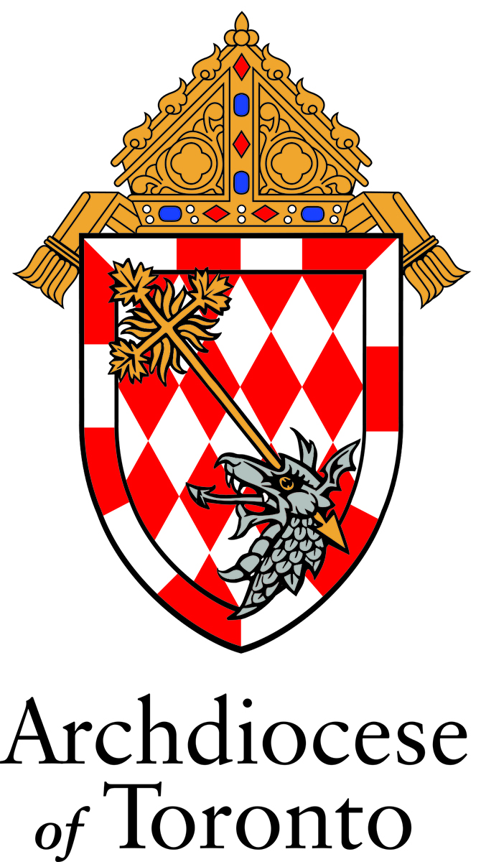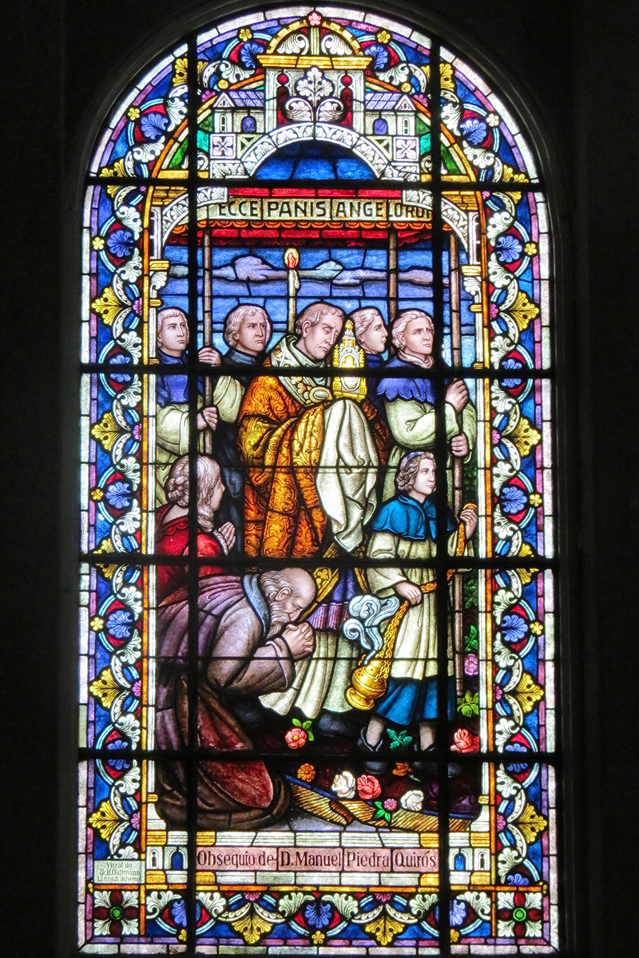

Resources for **Eucharistic Processions**

Contents

Eucharistic Procession FAQs 2

[Some Suggestions for Organizing a Eucharistic Procession  
in the 2025 Jubilee Year 4](#_Toc164360035)

Further Resources for Eucharistic Processions 7

Primary Items 7

Resources 7

Magisterial Documents 7

Papal Addresses and Resources 8

Prayers 8

# Eucharistic Procession FAQs

1. **What is a procession?**

The Church tells us that processions, in their true form, are a manifestation of the faith of the people. They are opportunities to deepen our faith in Christ, to unite with one another in a communal action and to witness to our faith. Over the centuries, the Church has instituted many processions. Some point to salvific events; others are votive processions, meaning that they honour a saint or liturgical feast; still others are required by liturgical actions (*Directory on Popular Piety,* 245-246*)*.

1. **What is a Eucharistic procession?**

A Eucharistic procession is a votive procession. It publicly and reverently honours the Real Presence of Christ in the Eucharist, which is the source and summit of our Christian life. It is a prolongation of the liturgy, during which the consecrated Host is carried in public allowing believers to “make public profession of faith and worship of the Most Blessed Sacrament.” (*Directory on Popular Piety*, 162) Votive processions have occurred since the Middle Ages.

1. **Why are there Eucharistic processions on the Solemnity of the Most Holy Body and Blood of Christ?**

Expressions of public piety and devotion to Christ present in the Eucharist reach back through centuries of Church history. Eucharistic processions on the Solemnity of the Most Holy Body and Blood of Christ developed as a public witness to the truth of Christ present in the Eucharist. The Latin Church has formally celebrated the Solemnity of the Most Holy Body and Blood of Christ (formerly *Corpus Christi*)since the year 1264. In the 16th and 17th centuries, public acts of piety and devotion to the Most Blessed Sacrament grew in response to challenges to the Real Presence (*Directory on Popular Piety*, 160-162, 246).

Processions on the Solemnity of the Most Holy Body and Blood of Christ continue today: “When it can be done in the judgment of the diocesan bishop, a procession through the public streets is to be held as a public witness of veneration toward the Most Holy Eucharist, especially on the solemnity of the Body and Blood of Christ.” (*Code of Canon Law*944.1)

1. **How can participation in a Eucharistic procession on the Solemnity of the Most Holy Body and Blood of Christ help me to grow in faith?**

St. Pope John Paul II taught that “The devout participation of the faithful in the Eucharistic procession on the Solemnity of the Body and Blood of Christ is a grace from the Lord which yearly brings joy to those who take part in it.” (*Ecclesia de Eucharistia*, 10) In this act of public worship, we experience being on pilgrimage, which is the Church’s condition. The People of God walks “with Christ and after Christ, aware that in this world it has no lasting dwelling. Through the streets of this earth it moves towards the heavenly Jerusalem.” (*Directory on Popular Piety*, 247) It is an opportunity to prayerfully walk with Christ, and to grow more deeply in love for Him.

1. **How would a parish organize a Eucharistic procession?**

A parish may consider establishing a Eucharistic Procession Committee to plan out the various elements, such as the procession route, the necessary municipal permits, parish groups coordination and promotion to elicit the participation of all within the parish community. The preparation for a Eucharistic procession can involve the participation of people with a variety of skills, including handiwork, building, sewing, organizing, musical and artistic and liturgical sensitivity.

The archdiocesan resource *Eucharistic Procession Ritual* provides details on the rubrics, liturgical objects, how to form a Eucharistic procession and suggestions of prayers and litanies to use while processing. *Suggestions for Organizing a Eucharistic Procession* offers more detailed information for a parish planning committee.

1. **How can the parish get involved in a Eucharistic procession?**

Every Eucharistic procession will reflect the unique characteristics of a parish community. Try to involve representatives from as many parish ministries, groups and associations in the planning process. Some suggestions include: liturgical ministers, parish committees, social groups, outreach ministries, youth ministry groups, lay associations, catechists, schools, retirement homes, Knights of Columbus, Catholic Women’s League, Legion of Mary, prayer groups and ministers of care.

# Some Suggestions for Organizing a Eucharistic Procession IN THE 2025 JUBILEE YEAR

1. **Collaborate.**

Consider establishing a Eucharistic Procession Committee, whose principal job it will be to facilitate the planning and execution of the many necessary details. Every Eucharistic procession will reflect the unique characteristics of a parish community. Try to involve representatives from as many parish ministries, groups and associations in the planning process. Some suggestions include:

* Liturgical ministers
* Parish committees
* Social groups
* Outreach ministries
* Youth ministry groups
* Those who have recently received First Holy Communion and Confirmation
* Lay associations
* Catechists
* Schools
* Retirement homes
* Knights of Columbus
* Catholic Women’s League
* Legion of Mary
* Prayer groups
* Ministers of Care

If your parish has established a Jubilee Committee, invite representatives to participate in the Eucharistic Procession Committee. They will be able to give an additional perspective to the planning process and identify “Signs of Hope” in the local parish community.

Consider having flowers thrown before the Blessed Sacrament in procession, perhaps by the children who have received their First Holy Communion this year.

A Eucharistic procession can involve the participation of people with a variety of skills, including handiwork, building, sewing, organizing, musical and artistic and liturgical sensitivity.

It is important to involve families in the planning so as to foster Eucharistic devotion in the domestic church as well.

1. **Plan.**

A Eucharistic procession involves a lot of planning. Some elements can be accomplished in a relatively short period of time and other elements may take more time to come together. Try to allow as much time as possible and add flex time for unforeseen delays.

When planning a Eucharistic Procession:

1. Determine the procession route.
   1. Will it be on the Church property or will it go into the neighbourhood?
   2. Consider Eucharistic Stations – how many and where?

In this Jubilee Year, if possible, consider including one or more “Signs of Hope”:

* + 1. Hospitals (sick, infirmed)
    2. Schools (youth)
    3. Retirement and long-term care homes (elderly)
    4. Food bank, mission (poor, homeless)

1. Obtain the necessary permits through the proper municipal office.
   1. This will vary depending on the city/town’s process so it’s best to look into this early in the planning process.
2. Communicate regularly with the parish community.
   1. Invite people to participate in subcommittee groups, e.g. building altars, flower arranging, reception committee.
   2. Encourage everyone to participate in the Eucharistic procession.
   3. Remind the community of the date and time and mark it in their calendars.
3. Consult the archdiocesan resource *Eucharistic Procession Ritual*
   1. for details on how to form a Eucharistic procession;
   2. for Eucharistic procession rubrics
   3. for details on what to do at a Eucharistic Station;
   4. for suggestions of prayers and litanies to use while processing.
4. Think of practicalities.
   1. Accommodating people who require assistance with accessibility.
   2. Programs or worship aids.
   3. Signage for routes.
   4. Assign individuals to keep the procession flowing at various points.
   5. A social reception with food and drink to encourage fellowship.
5. Be mindful of the details.
   1. Attend to them as they arise and communicate with the necessary people.
   2. Keep thorough notes and review frequently.
   3. Have a post-procession discussion meeting and note what when well and what could be done differently next year.
6. Keep your efforts focused on Christ and the glory of God.
7. **Communicate.**

Communication is key. A planning committee will quickly learn that planning a Eucharistic Procession is as much about getting permits, building altars, ordering flowers and printing booklets as it is about discovering the true identity of a community of believers, what aspects of discipleship really resonate with them and how they live the Gospel.

Some practical advice on effective communication include:

* Decide on the best person or people for the job and allow them the opportunity to use their gifts.
* Make use of varied methods of communication (digital, print, in-person and telephone) among committee members.
* Be creative and involve people who have creative abilities and gifts.
* Schedule regular meetings with the larger committee and with subcommittees.
* Set up social media channels and update them regularly.
* Update the parish community through the bulletin, website, bulletin boards and in pulpit announcements.

1. **Pray.**

Preparing a Eucharistic procession is true spiritual work and prayer is an indispensable component. Begin your planning meetings with prayer. In addition, the Archdiocese of Toronto has prepared a *Eucharistic Triduum* to be used in the three days leading up to the Solemnity of the Most Holy Body and Blood of Christ, referred to as the Feast of Corpus Christi.

# Further Resources for Eucharistic Processions

## Primary Items

* [Eucharistic Procession Ritual](https://drive.google.com/file/d/1t9sgUXE4TptCiOZbdUS8vPifsrM2r2lo/view?usp=sharing)
* [Eucharistic Triduum](https://drive.google.com/file/d/1w6HvnAGM6nTOSawCBibEijNftxcpyH0D/view?usp=sharing)

## Resources

* [Guide to Eucharistic Processions](https://www.kofc.org/en/resources/who-we-are/our-faith/eucharistic-procession-guidebook.pdf), Knights of Columbus
* [Eucharistic Processions – Tri-Fold Brochure](https://www.kofc.org/en/resources/faith-in-action-programs/faith/holy-hour/11334-eucharistic-procession-trifold.pdf), Knights of Columbus
* [Corpus Christi Procession](https://stpeterchurch.net/corpus_christi), St. Peter’s Catholic Church, Omaha
  + *Some best practices for processions that involve more than one parish*
* [The Origins of the Feast of the Corpus Christi](https://www.ewtnvatican.com/articles/origins-of-the-feast-of-the-corpus-christi-1055), EWTN Vatican Bureau, May 23, 2023
* [Solemnity of the Most Holy Body and Blood of Christ (Corpus Christi)](https://www.vaticannews.va/en/liturgical-holidays/solemnity-of-the-most-holy-body-and-blood-of-christ--corpus-chri.html), Vatican News
* [3 Powerful ways to celebrate Corpus Christi with children](https://aleteia.org/2023/06/10/3-powerful-ways-to-celebrate-corpus-christi-with-children/), Aleteia, June 10, 2023
* [National Eucharistic Revival](https://www.eucharisticrevival.org/?utm_term=eucharistic%20revival%20prayer&utm_campaign=Brand&utm_source=adwords&utm_medium=ppc&hsa_acc=7848429354&hsa_cam=20151220952&hsa_grp=155061135995&hsa_ad=676236322037&hsa_src=g&hsa_tgt=kwd-1960409642073&hsa_kw=eucharistic%20revival%20prayer&hsa_mt=b&hsa_net=adwords&hsa_ver=3&gclid=EAIaIQobChMI45Ho-qTggwMVS2lHAR0YfAnwEAAYASAAEgKO2_D_BwE), United States Conference of Catholic Bishops
* [How to Make a Canopy](https://www.rapidcitydiocese.org/wp-content/uploads/2019/05/Eucharistic-Processions-Canopy-Instructions.pdf), Diocese of Rapid City
* [Frequently Asked Questions about Eucharistic Processions](https://drive.google.com/file/d/1dGWQQeVbO9qS3Yui4lv7wvM1kMEgN8cT/view?usp=sharing)
* [Suggestions for Organizing a Eucharistic Procession](https://drive.google.com/file/d/1r32Wc6eX09arcXRbhk4ToeqL00p-myys/view?usp=sharing)

## Magisterial Documents

* Catechism of the Catholic Church
  + [The Sacrament of the Eucharist: 1322-1419](https://www.vatican.va/archive/ENG0015/__P3W.HTM)
  + [Worship of the Eucharist: 1378-1381](https://www.vatican.va/archive/ENG0015/__P41.HTM)
* Compendium of the Catechism of the Catholic Church
  + [The Sacrament of the Eucharist: 271-294](https://www.vatican.va/archive/compendium_ccc/documents/archive_2005_compendium-ccc_en.html)
  + [What kind of worship is due to the sacrament of the Eucharist: 286](https://www.vatican.va/archive/compendium_ccc/documents/archive_2005_compendium-ccc_en.html)
* [Mane Nobiscum Domine](https://www.vatican.va/content/john-paul-ii/en/apost_letters/2004/documents/hf_jp-ii_apl_20041008_mane-nobiscum-domine.html)*,* St. Pope John Paul II, October 7, 2004
* [Directory on Popular Piety and the Liturgy](https://www.vatican.va/roman_curia/congregations/ccdds/documents/rc_con_ccdds_doc_20020513_vers-direttorio_en.html), Congregation for Worship and the Discipline of the Sacraments, Vatican, 2001
* [Catechesis of His Holiness John Paul II on the Eucharist](https://www.vatican.va/holy_father/special_features/eucharist/documents/eucharist-audiences_en.html)
* [Dominicae Cenae](https://www.vatican.va/content/john-paul-ii/en/letters/1980/documents/hf_jp-ii_let_19800224_dominicae-cenae.html), John Paul II, February 24, 1980
* Inaestimabile Donum, Congregation for Divine Worship and Sacraments, 1980
  + Out of print. Reference copy available to clergy and parish leaders through the Office of Formation for Discipleship library. Contact [formation@archtoronto.org](mailto:formation@archtoronto.org)
* [Holy Communion and Worship of the Eucharist Outside of Mass,](https://www.liturgyoffice.org.uk/Resources/HCW/HCWE-Introduction.pdf) Congregation for Divine Worship, June 21, 1973

## Papal Addresses and Resources

* [Homily of His Holiness Pope Francis, Procession and Eucharistic Blessing, Archbasilica of Saint John Lateran, June 2, 2024](https://www.vatican.va/content/francesco/en/homilies/2024/documents/20240602-corpus-domini.html)
* [Homily of His Holiness Pope Francis, Holy Mass, Procession to Saint Mary Major and Eucharistic Blessing on the Solemnity of the Most Holy Body and Blood of Christ, May 26, 2016](https://www.vatican.va/content/francesco/en/homilies/2016/documents/papa-francesco_20160526_omelia-corpus-domini.html)
* [General Audience of 17 November 2010: St. Juliana of Cornillon (Benedict XVI)](https://www.vatican.va/content/benedict-xvi/en/audiences/2010/documents/hf_ben-xvi_aud_20101117.html)
* [Homily of His Holiness Pope Benedict XVI, Mass and Eucharistic Procession on the Solemnity of Corpus Domini, May 26, 2005](https://www.vatican.va/content/benedict-xvi/en/homilies/2005/documents/hf_ben-xvi_hom_20050526_corpus-domini.html)
* [*Pope Francis: Corpus Christi is a Call to Be Close to Others*](https://youtu.be/q-htikwALBU), Video by Robert Duncan, Additional Media provided by Vatican Media, © 2024 Catholic News Service

## Prayers

* [Litany of the Most Blessed Sacrament](https://drive.google.com/file/d/1is1cm7aSdDWc-91MXhs0q6lZX_kCnhpe/view?usp=sharing)
* [Litany of Our Lord Jesus Christ Priest and Victim](https://drive.google.com/file/d/1JLQV_TqisoCWbtcYzGD60iLFAZdGYrZc/view?usp=sharing)
* [Litany of the Most Precious Blood of Jesus](https://drive.google.com/file/d/1VAlKAV2HugESsq4hhNnh2xAzlYfsK2lc/view?usp=sharing)
* [Litany of the Most Sacred Heart of Jesus](https://drive.google.com/file/d/12GfDOcKHltq4zEdYU6KQOYqUbUhplZvb/view?usp=sharing)
* [Litany of the Most Holy Name of Jesus](https://drive.google.com/file/d/14m9lN21uKN78HAof0IRVil_NmFrL72pa/view?usp=sharing)
* [Litany of the Most Holy Eucharist](https://fdlc.org/wp-content/uploads/2022/11/Litany-of-the-Holy-Eucharist.pdf), Federation of Diocesan Liturgical Commissions
* [Pope’s Prayer Intention for A Eucharistic Life](https://www.youtube.com/watch?v=luckJcd1kc0), Pope Francis, July 2023
* [Anima Christi](https://drive.google.com/file/d/1auS1l_91zBrZhsS6Zo-gq6OkDOUqYbaE/view?usp=sharing), (may also be found in [Compendium of the Catechism of the Catholic Church, Appendix A](https://www.vatican.va/archive/compendium_ccc/documents/archive_2005_compendium-ccc_en.html#A)%20COMMON%20PRAYERS))